PROJECT: Linux IAM & Hardening mini

Submitted By:
Name: Bhavesh Verma
ERP:6604319
Course:ETH

- Project Overview
Objective:
To design and implement a secure user/group and permission model on an Ubuntu server, detect and fix 3 misconfigurations, and maintain evidence of all configurations and auditing.
Tools & Environment:
  - Ubuntu Server (Lab VM)
  - Kali Linux (Attacker VM – for testing)
  - sudo access enabled
- Baseline Policy Document
Role Privileges  Manage users, services, and | Sudo Access | File Access
Admin useradd, usermod, systemctl, apt Full access to /srv/project
software
Modify project files, restart systemctl restart/status Write to /srv/project, read-only
Dev
app service project.service only for others
Read logs and audit evidence Read-only /srv/project,
Auditor None
only /var/log/audit

- Implementation Steps
    - User and group creation
commands: sudo groupadd sudo useradd
    - Configure Sudoers (Least Privilege)
Created /etc/sudoers.d/roles-admin and /etc/sudoers.d/roles-dev

c) Step 3: Secure Project Directory sudo mkdir -p /srv/project
sudo chown :proj /srv/project sudo chmod 770 /srv/project sudo setfacl -m g:dev:rwx /srv/project sudo setfacl -m g:auditor:r-x /srv/project
Verification:
getfacl /srv/project
- Enable auditing sudo apt install auditd -y
sudo systemctl enable auditd --now sudo auditctl -w /etc/passwd -p wa -k identity sudo auditctl -w /etc/sudoers -p wa -k identity
- Vulnerability Discovery & Fixes

₁ World-writable /etc/cron.d/test Unauthorized users could add jobs sudo chmod 600 _{/etc/cron.d/test}
Sudo NOPASSWD for Privilege Removed from /etc/sudoers.d/roles-
2
devs escalation dev
Weak permissions on Read/write for all sudo chmod 770 /srv/project
3
/srv/project users and reset ACL

- Network Check
Scanned and Verified sudo ss -tulpn > ~/evidence/ports_after_closure.txt
sudo lsof -i -Pn > ~/evidence/open_sockets_after.txt sudo nmap -p 8080 127.0.0.1 > ~/evidence/nmap_8080_check.txt

- Remediation Checklist
Task Status

Remove world-writable files ✅

Disable unnecessary sudo NOPASSWD ✅
Lock down file permissions  Enable audit logging  Close unused ports  Generate evidence folder | ✅  ✅  ✅  ✅

h) Summary
Users: 3 created (alice, bob, charlie)
Groups: 3 configured (admin, dev, auditor)
Sudo rules: verified and validated
ACLs: configured correctly
Audit logs: functioning
Ports: secure, verified closed

Supporting ScreenShots:

1) Opening ports to listen through
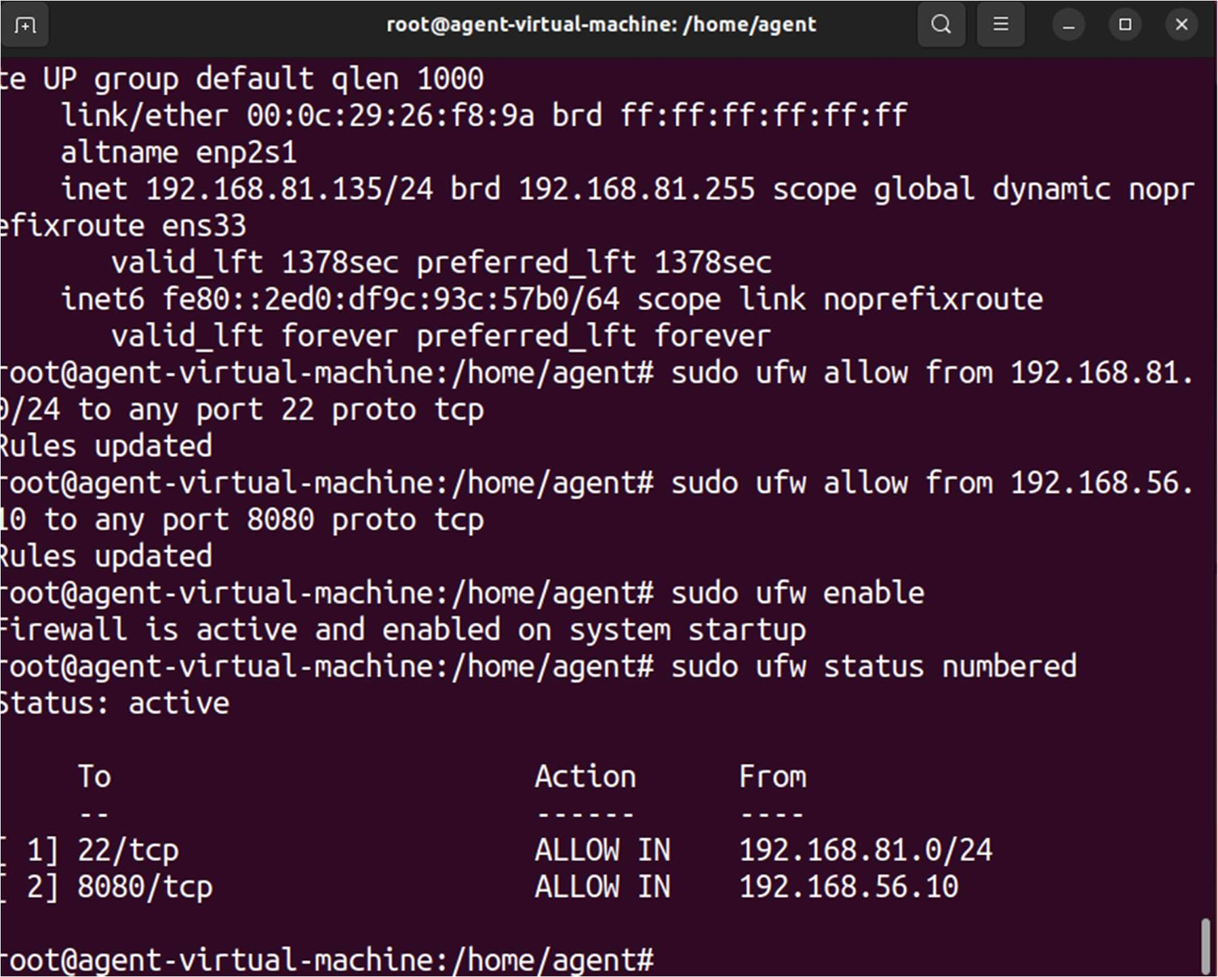

2) Open Ports Enumeration for System Hardening using ss Command
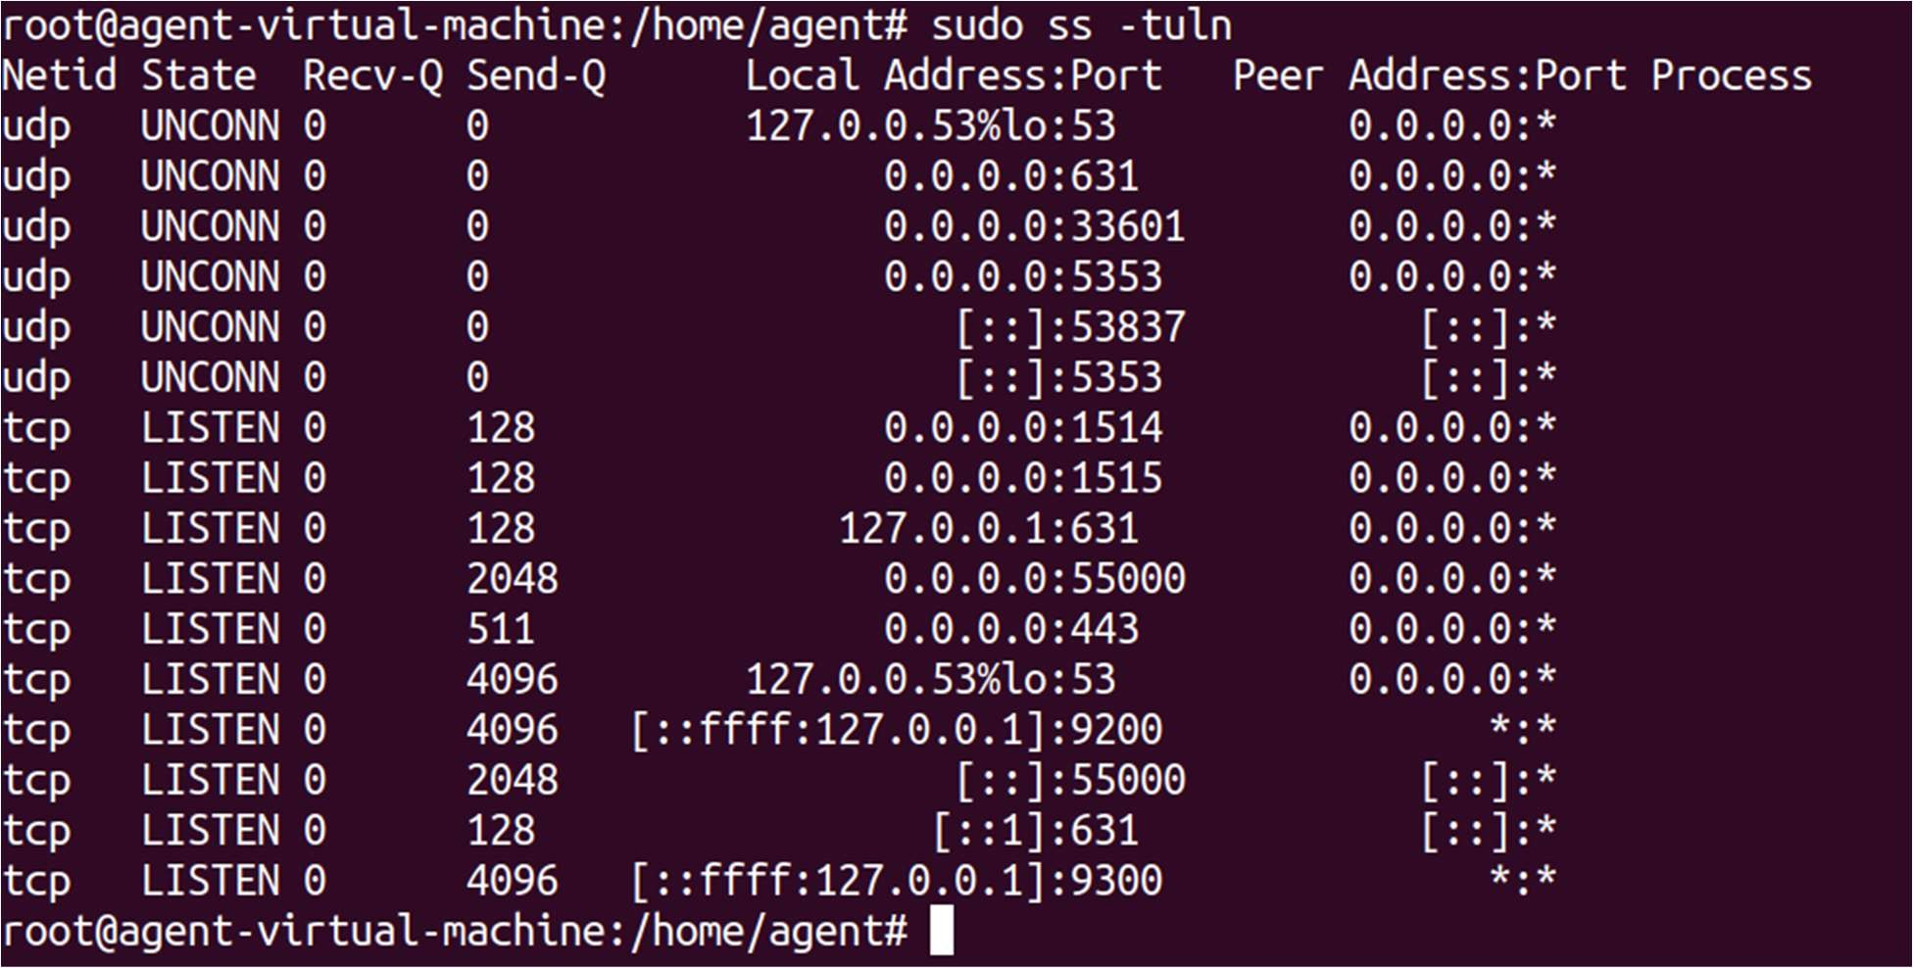

3) Nmap scan
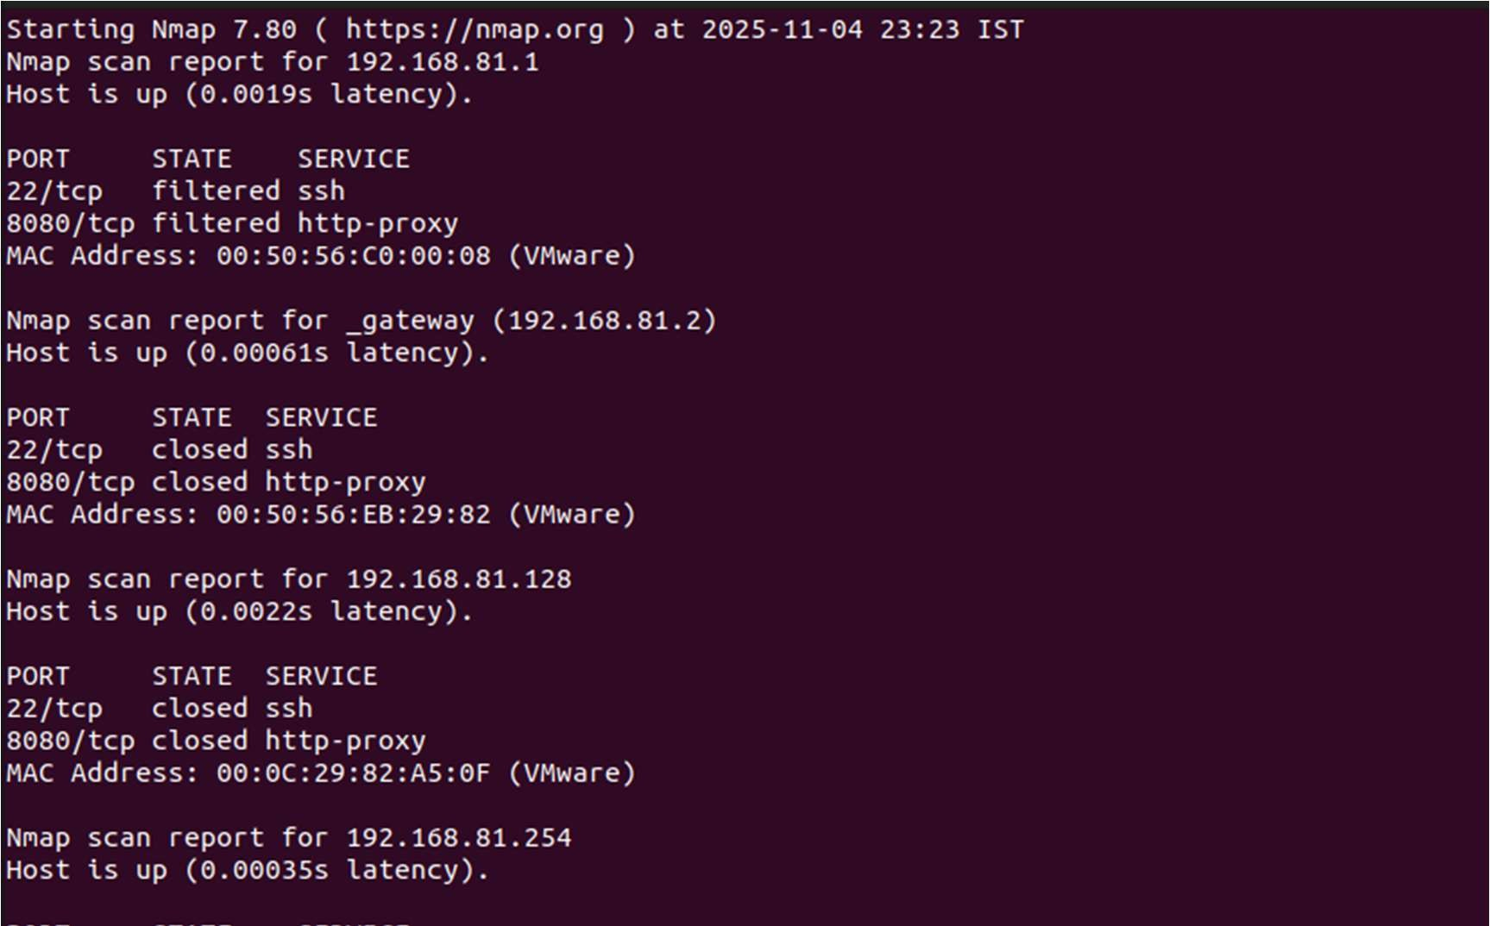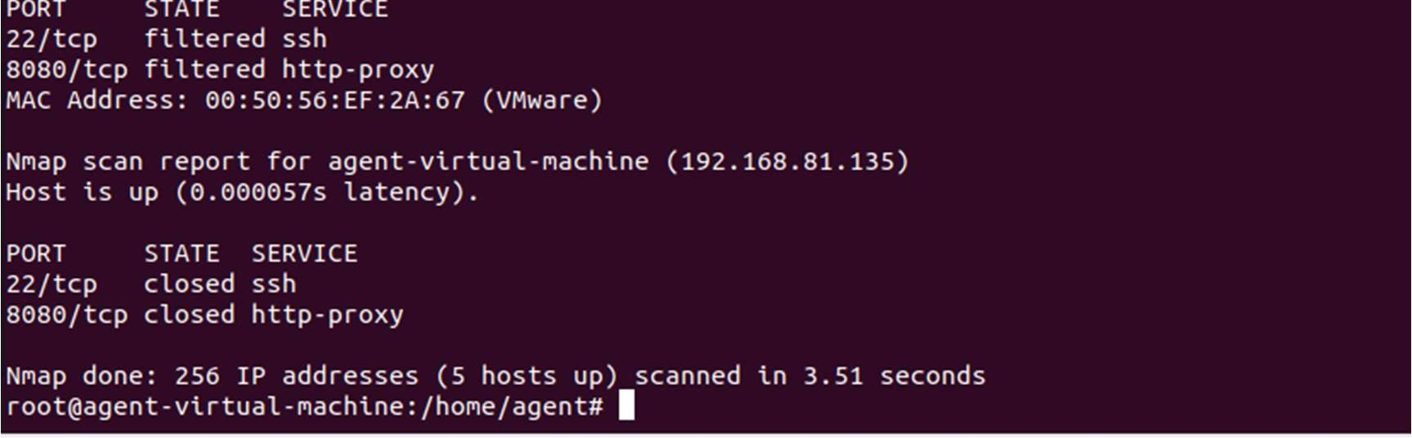

4) Nmap port scan command used to check specific ports (22 and 8080) on a target host
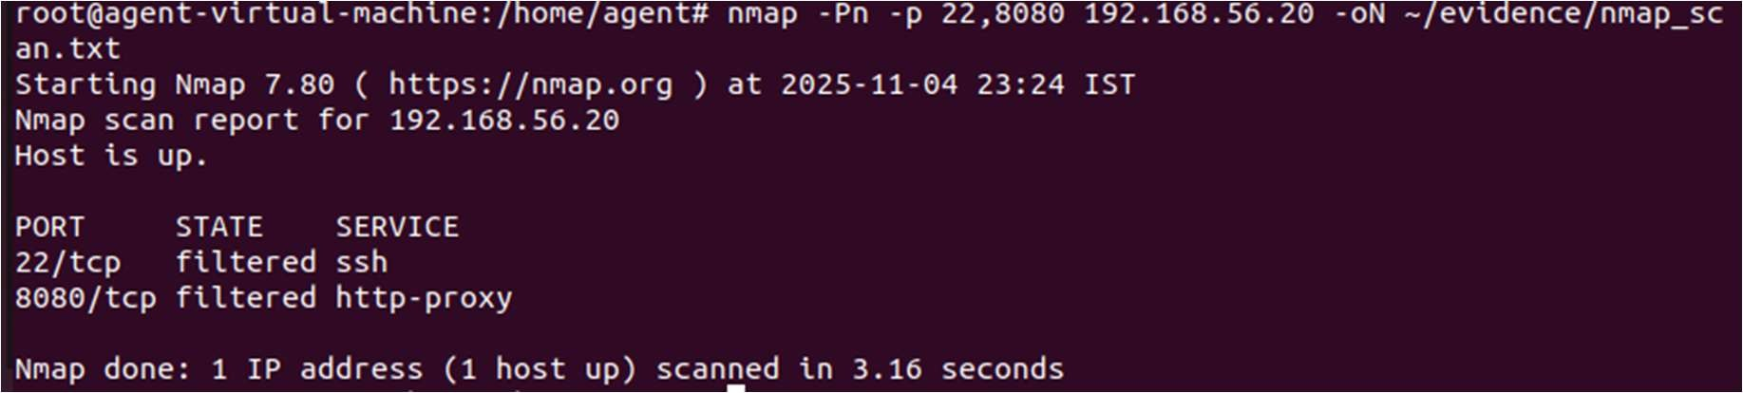

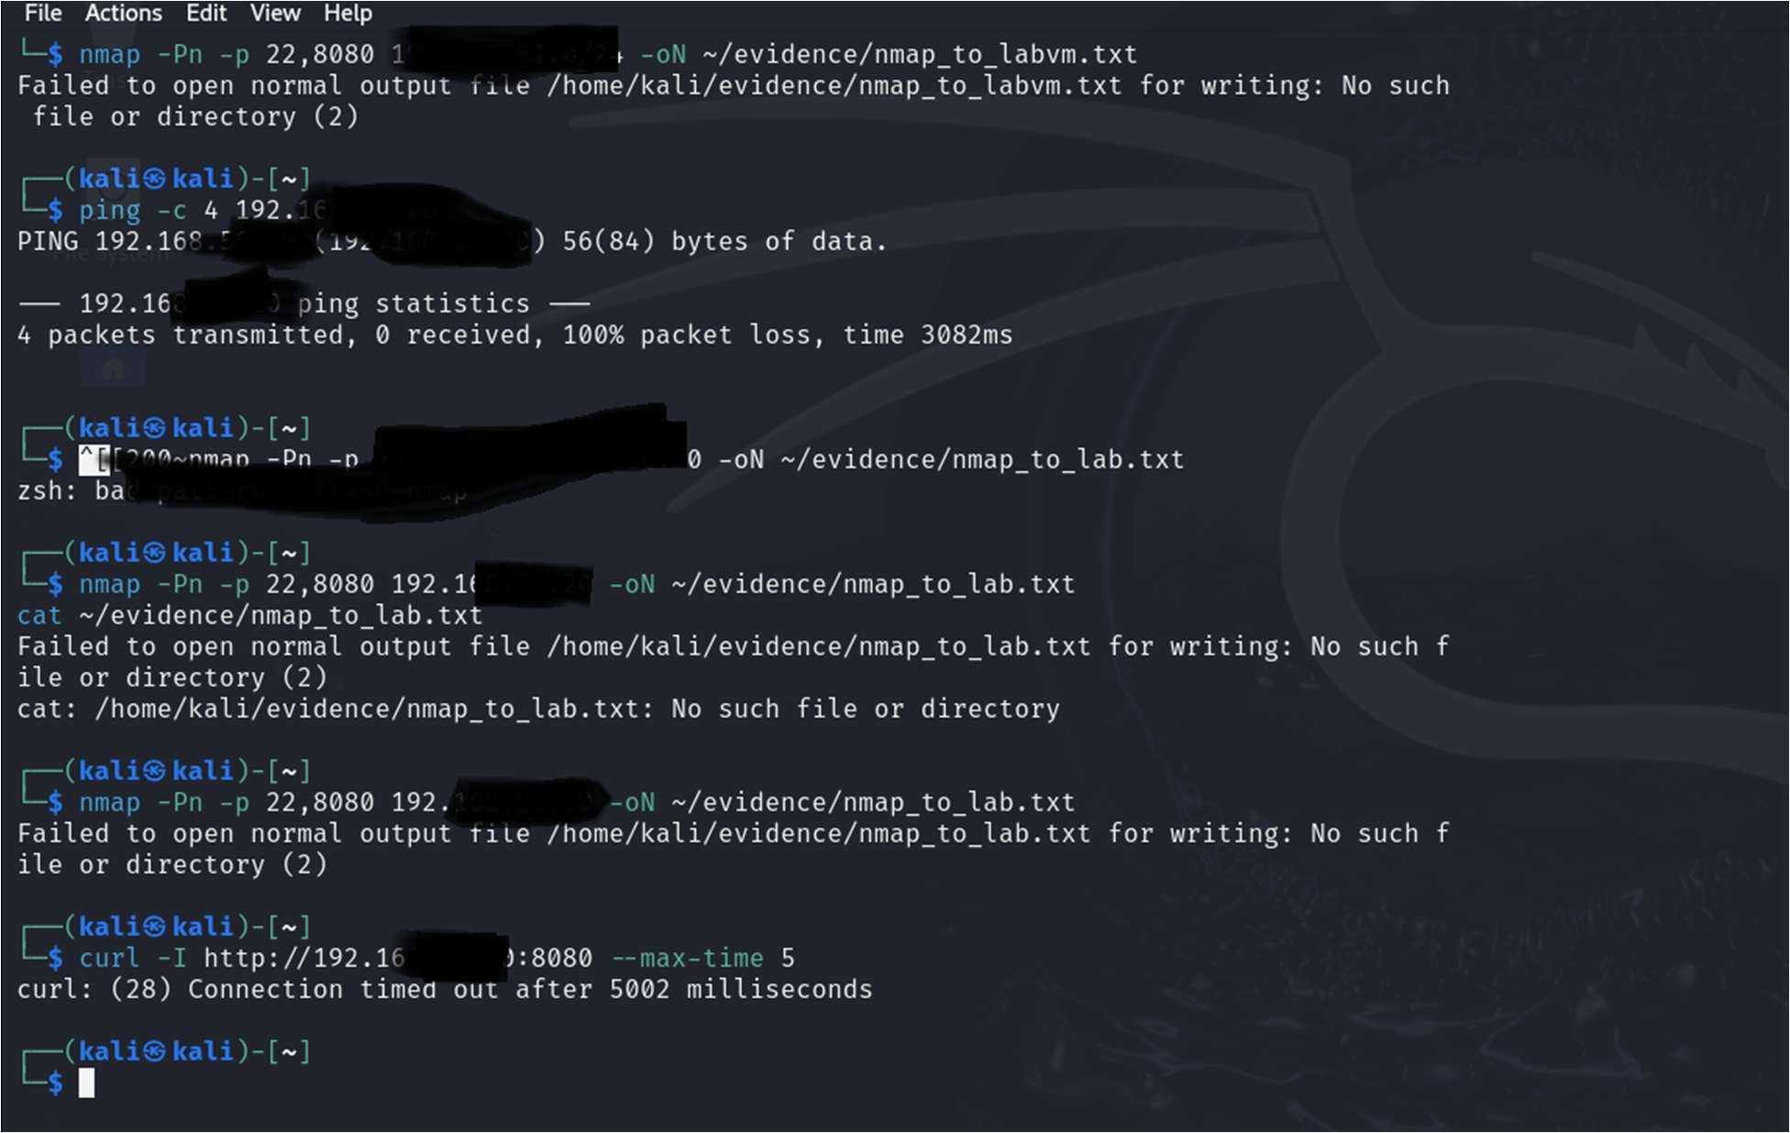
5)

Nmap scan from KALI LINUX

6) Verification of Service Termination and Port Closure using ss, lsof, and Nmap
